Earthing Practices
M V S Birinchi, CORE International, Inc. and TNEB course material
(Compiled and edited by Pradeep K. Srivastava, CORE International, Inc.)

Earthing Practices At Substations

Introduction

Earthing practices adopted at Generating Stations, Substations, Distribution structures and lines are of great importance. It is however observed that this item is most often neglected. The codes of practice, Technical Reference books, Handbooks contain a chapter on this subject but they are often skipped considering them as too elementary or even as unimportant. Many reference books on this subject are referred to and such of those points which are most important are compiled in the following paragraphs. These are of importance of every practicing Engineer in charge of Substations.

OBJECTIVE OF EARTHING

Prime Objective of Earthing is to provide a Zero potential surface in and around and under the area where the electrical equipment is installed or erected.

To achieve this objective the non-current carrying parts of the electrical equipment is connected to the general mass of the earth which prevents the appearance of dangerous voltage on the enclosures and helps to provide safety to working staff and public.

Importance of Earthing & Practices

- The earthing is provided for
- Safety of Personnel
- Prevent or atleast minimise damage to equipment as a result of flow of heavy fault currents.
- Improve reliability of Power supply

- The earthing is broadly divided as
- System earthing (Connection between part of plant in an operating system like LV neutral of a Power Transformer winding and earth).
- Equipment earthing (Safety grouding)
Connecting frames of equipment (like motor body, Transformer tank, Switch gear box, Operating rods of Air break switches, etc) to earth.

- The system earthing and safety earthing are interconnected and therefore fault current flowing through system ground raises the potential of the safety ground and also causes steep potential gradient in and around the Substation. But separating the two earthing systems have disadvantages like higher short circuit current, low current flows through relays and long distance to be covered to separate the two earths. After weighing the merits and demerits in each case, the common practice of common and solid (direct) grounding system designed for effective earthing and safe potential gradients is being adopted.

- Factors that change the requirement of earth electrode
- If an electrical facility can expand in system, it creates different routes in the electrode. What was formerly a suitable low earth resistance can become obsolete standard.
- More number of metallic pipes, which were buried underground become less and less dependable as effective low resistance ground connection.
- Most of the location, the water table gradually falling. In a year or two, area end up with dry earth of high resistance.
- These factors emphasize the importance of a continuous, periodic program of earth resistance testing.

- The earth resistance shall be as low as possible and shall not exceed the following limits:

Power Stations - 0.5 Ohms
EHT Substations - 1.0 Ohms
33KV Stations - 2.0 Ohms
D/t Structures - 5.0 Ohms
Tower foot resistance - 10.0 Ohms

Step Potential

Step Potential is the difference in the voltage between two points which are one metre apart along the earth when ground currents flowing.

Touch Potential

Touch Potential is the difference in voltage between the object touched and the ground point just below the person touching the object when ground currents are flowing.

Specification of Earthing

Depending on soil resistivity, the earth conductor (flats) shall be buried at the following depths.

Soil Resistivity in ohms/metre Economical depth of Burial in metres
1) 50 – 100 0.5
2) 100 – 400 1.0
3) 400 – 1000 1.5

To keep the earth resistance as low as possible in order to achieve safe step and touch voltages, an earth mat shall be buried at the above depths below ground and the mat shall be provided with grounding rods at suitable points. All non-current carrying parts at the Substation shall be connected to this grid so as to ensure that under fault conditions, none of these part are at a higher potential than the grounding grid.

Plate Earths

- Taking all parameters into consideration, the size of plate earths are decided as

Power Stations & EHT Station - Main - 100 x 16mm
Auxiliary - 50 x 8mm
Small Stations - 75 x 8mm

- The complete specifications for providing earth mats at EHT & 33KV Substations, Distribution transformers & Consumers premises are reproduced below.

Specification for Earthing System

I) EHT Substation

Earthing of equipment’s in the sub-stations is taken of as discussed below:

1. Power transformers:
- The transformer body or tank is directly connected to earth grid. In addition, there should be direct connection from the tank to the earth side of the lightning arresters.
ii) The transformer track rail should be earthed separately.
iii) The neutral bushing is earthed by a separate connection to the earth grid.

2. Potential and current transformers :
The bases of the CTs and Pts. are to be earthed. All bolted cover plates of the bushing are also to be connected the earth grid.

3. Lightning arresters :
The bases of the L.As. are to be earthed with conductors as short and straight as Possible (for reducing impedance). The earth side of the L.As. are to be connected directly frolJ1 the equipment to be protected. Each L.A. should have individual earth rods, which are in turn connected to earth grid.

4. Circuit breakers:
The supporting structures, C.T. chambers, P.T. tanks, Cable glands etc., are to be connected to earth.

5. Other equipment’s:
All equipment’s, structures, and metallic frames of switches and isolators are to be earthed separately.

6. Fences:
Providing separate earth or connecting to the station earth depends upon the distance of the fence the station earth. If the distance is within feet, an inter-connection made to the station earth. If not, the metallic fences are earthed by means of earth rods spaced at not more than 200 feet. The gates and support pans may be earthed through an earth rod. The cable wires passing under “metallic fence are to be buried below at a depth qf 2’6 or are to bc enclosed in a insulating pipe (P. V.C or asbestos cement) for a distance of not less than 5 feet on each side of the fence.

7. Ground wires :
The ground wires over the station arc connected to the station earth. In order that the station earth potentials during fault condition5 arc not applied to transmission line ground wires and towers, all ground wires coming to the stations shall be broken !It an insulated on the fir5t tower external to station by means of strain disc. insulators.

The followings are the important features in earthing:

- The earth mat shall be as per the approved layout. The earth mat shall be formed with the steel flats buried in the ground at a depth of 750mm on edge.

- The earth mat shall extend over the entire switchyard as per the layout.

- All the junctions of the steel flats while forming the earth mat and taking risers from the earth mat for giving earth connections to equipment, steel structures, conduits cable sheaths shall be properly welded. All joints shall be provided with suitable angle pieces for proper contact between flats.

- Provisions shall be made for thermal expansion of the steel flats by giving smooth circular bends. Bending shall not cause any fatigue in the material at bends.

- The earth mat shall be formed by welding 50x8 mm steel flat to the 100 x 16mm peripheral earth conductor. The grounding grid shall be spaced about 5 meters i.e in longitude and about 5 meters in the transverse directions. After the completion of earth mat, the earth resistance shall be measured. In case the earth resistance is more than one ohm the earth mat shall be extended by installing extra electrodes, so that the earth resistance is less than one ohm.

- All fence corner posts and gate posts shall be connected to the ground by providing 32mm dia M.S rods of 3 metre length near the posts and connected to the main grounding mat.

- All paint enamel and scale shall be removed from surface of contact on metal surface before making ground connection.

- The risers taken along the main switchyard structures and equipment structures (upto their top) shall be clamped to the structures at an interval of not more than one metre.

- 50 x 8mm ground conductor shall be run in cable routes and shall be connected to the ground mat at an interval of 10 metres.

- Grounding electrodes of 32mm dia 3mtr. long MS rods shall be provided at the peripheral corners of the earth mat. The grounding rods shall be driven into the ground and their tops shall be welded to clamp and the clamp together with the grounding rods shall be welded to the ground mat.

- Lightening arrestors shall be provided with earth pits near them for earthing.

- Cast iron pipes 125mm dia and 2.75 metres long and 9.5mm thick shall be buried vertically in the pits and a mixture of Bentonite compound with Black cotton soil a ratio of 1:6 is to be filled 300 mm dia and the pipe for the entire depth. Where it is not possible to go to a depth of 2.75 metres, 1.3 x 1.3 MMS plates, 25mm thick shall be buried vertically in pits of 2 metres depth and surrounded by Bentonite mixture atleast 2 metre away from any building or structure foundation. The plates shall be atleast 15 metres apart. These earth pits in turn shall be connected to the earth mat.

II) Earthing at 33KV Substations

1. Providing of earth pit and earth matting include the following connected works:

- Excavation of earth pits of size 21/2ft x 21/2ft x 9ft in all type of soils.
- Providing of CI pipe of 3 inch diameter 9ft length with flange. All connections to CI pipe shall be with GI bolts and nuts.
- Filling of earth pit excavated with Bentonite with Black cotton soil (1:6) in alternate layers.
- Providing of cement collar of size 2ft diameter 2ft height 1 inch below the ground level.
- The top of the CI earth pipe should be at the surface level of the ground.

2. Providing of earth matting with MS flat 75 x 8mm including the following connected works:
- Excavation of trench in all types of soils of size 2½ ft depth and 1 ft. width.
- Laying of M.S flat 75 x 8mm in the excavated trench.
- Inter connecting all earth pits and welding properly at jointing location and junctions.
- Back filling of earth completely.

III) Earthing at Consumer’s premises

The earthing at Consumer’s premises shall be as per sketch below using a 6mm thick plate

IV) Earthing at D/P Structure

Three electrodes forming an equilateral triangle with minimum distance of 6500 mm, so that adequate earth buffer is available. Each Electrode shall be ‘A’ grade GI pipe of 2 inch thick and 8ft long and buried vertically so as to leave about 4 inch pipe length above ground level to fix a ‘U’ shaped clamp.
Note:

1. The connections to the three earth conn.Electrodes should be as follows.

(A) To one of the earth electrodes on either side of double pole structure (X or Y)

- One direct connection from three 11KV Lightening Arrestors.
- Another direct connection from the LT lightening Arrestors if provided.

(B) To each of the remaining two earth electrodes.

- One separate connection from neutral (on the medium voltage side) of the Transformer (Two wires)
- One separate connection from the Transformer body and the handle of the 11KV A.B switch (Two separate body earths to tank)
- One separate connection from the Earthing Terminal of poles.

(C) 4mm G.I wire should be used for earth leads.

Joints

- There shall be minimum joints preferably no joints enroute to earth electrodes
- Where Joints are unavoidable, they shall be brazed, rivetted or welded (and painted with red lead and alluminium paints one after the other and finely coated with bitumen)

Tower Line Grounding

- Ground rods are driven at the base of the tower. Where it is not feasible, an electrode is located within a distance of 200 ft. of the tower and grounding rods are provided at that point and tied to the tower base by a single buried wire.
- If low resistance is not obtained with 200ft, crowfoot counterpoise with 4 wires is installed. The counterpoise conductors shall be 6 SWG galvanised steel wires taken away from the tower at mutually right angles and kept at least 50ft apart. Each of these wires is terminated at a rod at the nearest point where low resistance is obtained. If counterpoise wires cannot be terminated within half span from the tower the wire is carried through a continuous counterpoise to the next tower, where the procedure is repeated.

Earth Mat Design

Earthing System in a Sub Station comprises of Earth Mat or Grid, Earth Electrode, Earthing Conductor and Earth Connectors.

Earth Mat or Grid

Primary requirement of Earthing is to have a low earth resistance. Substation involves many Earthings thro’ individual Electrodes, which will have fairly high resistance. But if these individual electrodes are inter linked inside the soil, it increases the area in contact with soil and creates number of parallel paths. Hence the value of the earth resistance in the inter linked state which is called combined earth value which will be much lower than the individual value.

The inter link is made thro flat or rod conductor which is called as Earth Mat or Grid. It keeps the surface of substation equipment as nearly as absolute earth potential as possible.

To achieve the primary requirement of Earthing system, the Earth Mat should be design properly by considering the safe limit of Step Potential, Touch Potential and Transfer Potential.

Step Potential
It is the potential difference available between the legs while standing on the ground.

Touch Potential

It is the potential difference between the leg and the hand touching the equipment in operation.

The factors which influence the Earth Mat design are:

- Magnitude of Fault Current
- Duration of Fault
- Soil Resistivity
- Resistivitiy of Surface Material
- Shock Duration
- Material of Earth Mat Conductor
- Earthing Mat Geometry

The design parameters for the following can be worked out as given in the annexure I

- Size of Earth Grid Conductor
- Safe Step and Touch Potential
- Mesh Potential (Emesh)
- Grid configuration for Safe Operation
- Number of Electrodes required

Measurement of Earth Resistance

The measurement of earth resistance is done using three terminal earth meggars or four terminal earth meggars.

Three Terminal: Two temporary electrodes or spikes are driven one for current and the other voltage at a distance of 150 feet and 75 feet from the earth electrode under test and ohmic values of earth electrode is read in the meggar.

Four Terminal: Four spikes are driven into the ground at equal intervals. The two outer spikes are connected to current terminals of earth meggar and the two inner spikes to potential terminals of the meggar till a steady value is obtained.

Marking
(i) For 3 Terminal Meter (ii) For 4 Terminal Meter
Current Terminal – C or H Current Terminal C1, C2
Potential Terminal – P or U Potential Terminal P1, P2
Earth Terminal – E

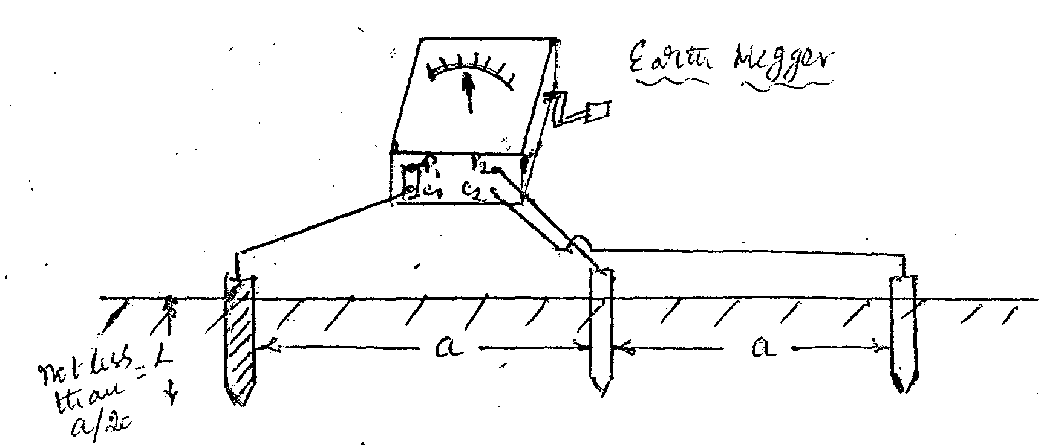
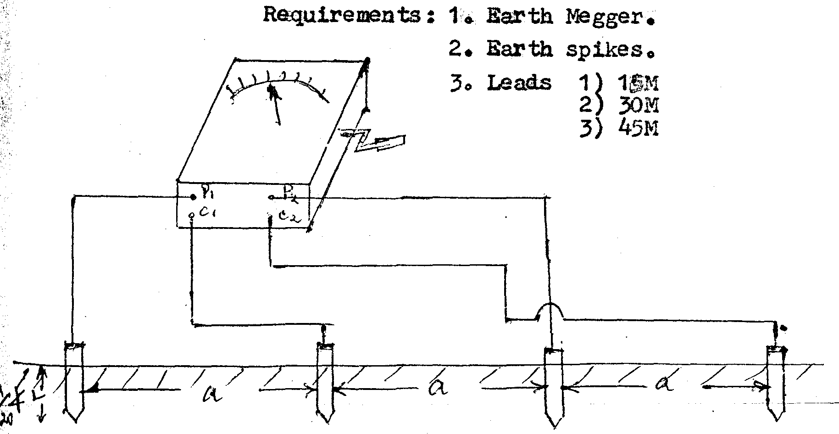

Maintenance of Earthing System

Checking and Testing
The Earthing systems are to be inspected regularly. Regular checking or joints and broken connections, if any and rectifying the same will prove to be of immense help in maintenance of earth grid and equipment’s. The condition of the electrodes, joints are also to be checked. If the electrodes are’ corroded immediate steps for replacement are to be taken. The earth resistance is to be measured periodically. The megger, or testers are used for this purpose.

As discussed earlier, low earth resistance Path is a must for clearing the fault current instantaneously. For achieving -low earth values, the following ways are followed:
- A number of electrodes are connected in parallel thereby providing a low resistance.
- The ground surrounding the electrodes is treated with common salt which reduces the resistance by 80%. Calcium chloride and magnesium sulphate may also be used. In general practice. But now the bentonite is used.

The following Maintenance schedule in mandatory at each of the Substations

S.No | Item | Periodicity
1. | Watering of Earth Pits | Daily
2. | Measurement of earth resistance of individual earth pits | Half yearly @
3. | Measurement of combined earth resistance at all the pits | Half yearly...
4. | Checking of inter connections between earth pits and tightness of bolts and nuts | Quarterly

@ Earth resistance of individual earth pits can be measured by disconnecting the earth connections to the electrode. This is possible if the connections are made to a common clamp which is in turn is fixed round the pipe.

... Combined earth resistance shall be the same at every earth pit unless it gets disconnected from the earth mat

Definitions of General Earthing Terms

Soil Resistivity: This is the resistivity of a typical sample of soil

Earth Surface Voltage: The voltage between a specified point on the ground around the rod and reference earth.

Earth Electrode

These are conductors, which are in direct contact with the soil and provide the conductive part in electrical contact with earth. They can include rods, tape, steel reinforcing bars.

Definitions of Terms associated with Power Systems

Neutral Point

The common point of a star connected poly phase system or the earthed mid-point of a single phase system.

Independent Earth Electrode

An earth electrode located at such a distance from other electrodes that its electrical potential is not significantly affected by electric currents between Earth and other electrodes.

Exposed Conductive Part

Conductive part of equipment and which is not normally live, but which can become live when basic insulation fails.

Points of Earthing

- Earth mat of 75 x 8 MS flat should be laid as outer of the switchyard compulsorily and see that the pole structures are enclosed in the outer mat.
- Make vertical and horizontal sections for the outer mat as shown in the fig. The internal vertical and horizontal sections may be 75 x 8 or 50 x 6 MS flat.
- The Earth mat should be laid minimum 600MM, below the ground level under the Earth mat and Bentonite powder is to be laid upto 25mm and over the earth mat. The same Bentonite compound with Black cotton soil a mixture of 1:6 ratio is to be placed upto 100 mm and the remaining earth trench is to be back filled with the soil.
- See that each and every pole structure is earthed with 50 x 6 MS flat to the Earth Mat.
- For every breaker there will be fine earth connections to the earth mat with 50 x 6 MS flat (a) Breaker body (b) Relay Panel (c) CT’s of the Breaker (d) and two sides of the breaker structure.
- Lightening arrestor is to be connected one end directly to the earth mat and the other end is to the nearer earth pit or to the earth mat.
- Line Isolators are to be connected directly to the earth mat.
- The Power transformer body is to be connected two sides to the earth mat.
- Twin neutral earthing should be done to Power Transformer as shown in the fig. one Earth flat of size 75 x 8mm M.S flat is directly connected to the earth pit and the earth pit is again connected to the Earth mat. The second neutral is directly connected to the earth mat,
- Provide flexible jumpers thoroughly brazed as shown in figure
- All AB switches operating rods are to be provided with coil earths and the AB switch support is to be earthed to the earth mat.
- All the exposed earth flat, which is dropping down from the breakers, CT’s structures should be applied with bituminous paint.
- 75 x 8 MS flat is to be laid around the control room from main earth and the panels of the breakers, midpoint of the Battery and Battery stand structures are to be earthed to the earth flat and make a section in front of the control room.
- The distance between any two earth electrodes should be twice the length of the Electrode.
- The cable (11 x 33KV) sheaths are to be earthed with 25 x 3 GI strip to the Earth mat.
- The neutral of the station transformer is to be connected to the Earth mat directly with 25 x 3 GI strip. The body of the Station transformer two sides to be connected to the earth mat with 25 x 3 GI strip.
- All the welding joints should be painted with bituminous paint.

V. CONCLUSION

The various practices and standards are to be followed in respect of providing Earthing in our systems. If proper Earthing is not done, there is every likelihood of equipment’ I getting damaged and also have to be personnel -public and staff. Hence due attention is to be given in providing and maintaining of earth grid properly and in good condition.

Annexure I

Calculation of design parameters for the earthing is given below:

Data Needed

- Soil Resistivity
- Resistivity of Crushed Rock
- Crushed Rock Surface Layer Thickness
- Switch Yard overall Dimensions
- Earth Fault Level
- Duration consider for earth fault.

I. CALCULATION OF SIZE OF EARTH GRID CONDUCTOR

Conductor Area A = I

Tcap x 10 ^{–4} x ln Ko + Tm
tc – α _{r} x Pv Ko + Ta
Simplified formula for Steel Grid Conductor
Area A = I x √t
K
Where A = area of earth conductor in mm².
I = short circuit current in KA.
t = duration of short circuit current in seconds.
K factor = 80 for steel.

If mat is made of Flat then

A = Area of Flat

Give allowance of 35 % for corrosion

If it is a conductor

A = pie  r²
r = √A/pie

STANDARD FLATS

- 10 x 6 iv) 40 x 6 vii) 60 x 6
- 20 x 6 v) 50 x 6 viii) 65 x 10
- 30 x 6 vi) 50 x 8 ix) 75 x 10

ROD
40 mm Mild Steel Rod

II. Determination of Maximum Permissible Step and Touch Potential

E step = ( 1000 + 6  _{s} x P_{s} ) 0.116
t

where P_{s} = Resistivity of Crushed Rock
❒ _{s} = Reduction factor for derating the value of surface layer is a function of reflection factor ‘K’ of crushed rock.

K =        –  _{s}
❒ +  _{s}

where    is the Soil resistivity
❒ _{s}  is the resistivity of Crushed Rock
To plot the value of  _{s}  
Refer the graph fig. 8 of page 41 of I EEE 80.
At hs = ? and K = ?
Calculate  _{s}  
Then calculate
E step = ( 1000 + 6  _{s} x P_{s} ) 0.116
    √t

Similarly

E Touch = ( 1000 + 6  _{s} x P_{s} ) 0.116
√t

    Calculation of Mesh Potential
Em = Km K i P IG.
L

where Km = Geometrical Factor
Ki = Correction factor for Grid
IG = Maximum earth fault current in amps.
L = Total Length of Conductor in metres.

The value of Km can be calculated from the formula
Km = 1 Ln D² + (D + 2ho) ² - h + Kij ln 8
2Π 16 hd 8 Dd 4d Kn Π (2n-1)

Where Kn = √ 1 + h/ho

Where h = depth of buried conductor
ho = reference depth
D = Spacing between the Grid
d = diameter of earth conductor
n = no. of parallel conductor
Calculate Km = ?
Ki = correction factor for grid geometer
Ki = 0.656 + 0172 n
I G = Current Diversion Factor which is 60% full load current
So
Em = P x Km x K i x I G Volt
L

The Mesh Potential always less than the permissible touch & step potential. Then only the design is considered as safe.

Calculation of Number of Electrode

R = 100  x ln 4l ohm
d

Minimum No. of parallel electrodes needed = Value of R

Earth Electrodes

Stations Plate Electrodes Pipe electrodes

a) Larger Power Stations G.I. Plates of 120 x 120 cm and i)G.I. Pipes of 152mm dia
and Major sub-stations 12.5 mm thick x 3.048mts. long and not less than 12.5. thick.

ii) In case of G .I. or
steelpipes, not smaller
than 38mm internal
diameter.

b) Small sub-stations 60 x 60cm G.!. plates of 9.4 mm G.I. pipes of 50.8 min thick internal diameter and
3.058mts., long.

Earth conductors

a) Main and subsidiary connection : Cross Section not less than 161sq. cm;{Copper)
b) Branch connections : Cross section not less than 64.5 sq. cm.

